

Richard Sylvester, Ph.D., M.P.

1401 North 7th St. Suite B

West Monroe, Louisiana 71291

Tel: (318) 503-8300

Fax (318) 503-8302

**REFERRAL FORM**

Please complete the entire form. We need it to help your patient. We must fax the form back if information is missing because we want to be of service to you and your patient.

**Reason for Referral:**

**Patient Information**

Patient Name: Diagnosis upon referral:

Date of Birth:

Address: 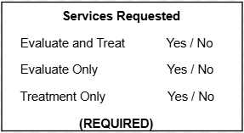

Phone Number:

Contact Person:

(IF MINOR CHILD)

**Insurance Information**

Insurance Carrier: Policy Number:

Group Number: Insurance Phone Number:

Policyholder Name: Policyholder Date of Birth:

**Referring Providers’ Information**

Referring Provider Name: Collaborating Physician:

Referring Provider’s Phone: Fax:

Signature of Referring Provider: Date:

If you are a nurse practitioner, does the collaborating physician concur with this referral? Yes / No

Finally, please send all records with a list of all current medications with the referral.